# Lawrence Zhou – Critique Data Visualisations Assignement

## Visualisation 1 – mRNA-2173 Covid-19 Vaccine

**Introduction:**

The mRNA-1273 vaccine is a COVID-19 vaccine being developed by The United States National Institute of Allergy and Infectious Diseases (NIAID), the Biomedical Advanced Research and Development Authority (BARDA), and Moderna. This will be the series of visualisations being examined, showcasing the adverse effects of the mRNA-1273 vaccine on humans.

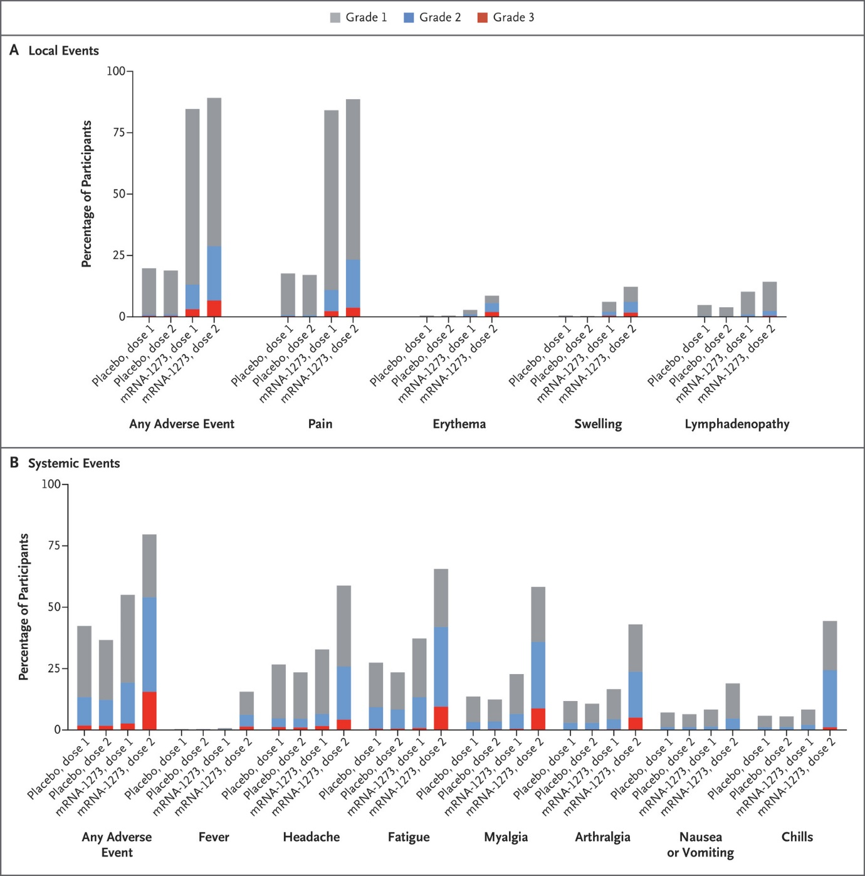

This graph is primarily split between two sections, showing the local and systemic adverse effects of the mRNA-2173 vaccine on humans (with a horizontal split). The first point of contention with the data visualisation is the usage of hue. They have separated the severity of pain via using different colours: Grade 1 is grey, Grade 2 is blue, Grade 3 is red. Grade 1 uses a colour that most blends in with the white background (being the grey colour). This leads people to believe that most adverse effects that are in Grade 1 are not significant and can very easily be dealt with. Grade 2’s colour, whilst not blending in as much as the grey, still easily blends in with the background. This signifies that whilst the adverse effects on these people is more severe than Grade 1, it is still insignificant. Grade 3’s colour, on the other hand, is the only colour used in the bar chart that contrasts the white background, highlighting the gravity of the effects on the person. The colour choices used are effective in that they can be used for anyone who is Red-Green colour-blind; the blue colour will stay blue, whilst the red will turn into a different colour. Another way of expressing this information would be through opacity or saturation, where instead of using specific colours, lighter and darker versions of a singular colour would be used to display the number of each type of adverse effects on the volunteers.

The graph itself is a grouped bar graph, grouping each of the injections under the each of the local and systemic adverse effects. Separation among the Local Events and Systemic Events Bar Graphs are inconsistent, with the number of adverse effects being different in each graph. Because of this, the “Local” adverse effects are much clearer than the “Systemic” adverse effects. The only thing differentiating the grouped bar graphs is the bolded names of the effects beneath each group. One way to counter this is to leave no separation in between the bars in each group, leaving an outline of each bar to separate the 4 categories. With this, separation between each group is still inconsistent with both graphs, which may allow for more attention to be paid towards only the Local Events as well. On the other hand, data density is much lower on the “Local Events” bar graph when comparing to the “Systemic Events” bar graph, with much more white space in between. Another recommendation is for opacity/saturation to be used instead of hue (with different colours for each group) to be able to more effectively separate each group from each other aside from the names of the effects.

The x and y-axes are in black, and potentially provide too much contrast between itself and the background. Whilst the words “Percentage of Participants” and the names of each category in each group do provide significance in that it provides information about what the axes mean, the axes itself does not help with this. The y-axis (And the percentages associated with them) and the x-axis should instead use a grey colour to be able to blend into the background, allowing the user to focus more on the contents of the bar chart itself. Each tick on the y-axis is separated by 25 percent. Despite the user being able to less accurately see the results, a separation of this size will be able to save ink (using the data-ink ratio), as less ticks are used overall in each graph of the visualisation.

The way that the data visualisation separates the legend, and the two graphs is through boxes, with its outlines being a solid black colour. Whilst it is effective in its job of separating each of the graphs, it may not be ink effective. One recommendation is to have dashed lines separating the “Systemic events” bar chart and the “Local events” bar chart instead of solid lines. This allows for some distinction against the separation of the “Local events” bar chart and the legend. The very top and bottom horizontal lines may be removed alongside the two vertical lines. This is because they provide no separation between any of the three sections in the visualisation.

## Visualisation 2 – BNT162b2 mRNA Covid-19 Vaccine

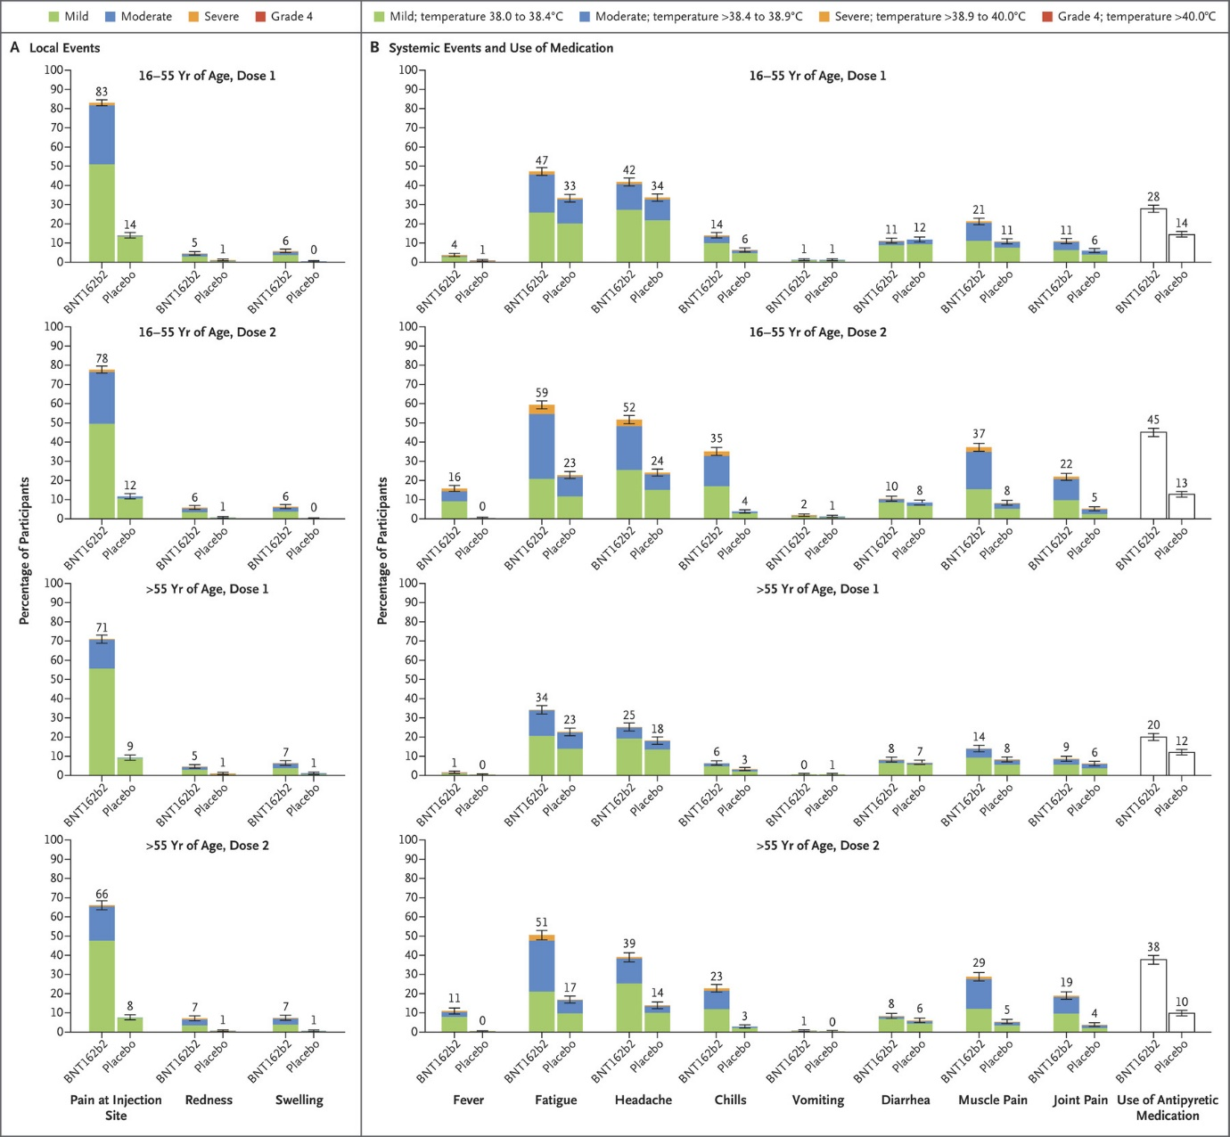

**Introduction:**

The BNT162b2 mRNA Covid-19 Vaccine is developed by Pfizer, one of the largest biopharmaceutical companies in the world. This will be the series of visualisations being examined, showcasing the adverse effects of the BNT162b2 mRNA Covid-19 Vaccine on humans.

This data visualisation is primarily split between two sections, showing the local and systemic adverse effects (alongside usage of medication) of the mRNA-2173 vaccine on humans (with a vertical split). The first comparison that could be made between this visualisation and the first one is the split between ages of over and younger than 55 years of age. This then shows the effects of the virus on the different age groups and how they differ. This then allows them to more accurate visualise the chance of experiencing a particular symptom. The first visualisation, on the other hand, collates and averages all the data together to produce a visualisation about all participants overall. Another thing that the second visualisation does is collate the “Use of Antipyretic Medication”, to see how the adverse effects of the Systemic Events are potentially affecting the severity of the side effects of the vaccine. The bar graphs are whited out, as they do not provide any data about the gravity of the adverse effects.

The usage of hue is quite effective in this visualisation. They separate 4 different colours for the 4 different severities of adverse effects. (Green = Mild, Blue = Moderate, Yellow = Severe, Grade 4 = Red). This allows people to believe that the Mild/Moderate, despite being there, can very easily be dealt with. The yellow and red, despite being more severe, are much less common to come across overall. This may also be useful for people who may be red-green colour-blind. The green and blue will blend into a blue colour, whilst the red and yellow will blend into a yellow colour. Whilst it is much easier to separate the first two with the second two severities, it might be more difficult to separate the “Mild” with the “Moderate” severities and the “Severe” and “Grade 4” severities. Because of this, usage of saturation or opacity instead of hue might be a better option, allowing for a separation for all 4 groups for red-green colour-blind people.

The legend is located at the top of both visualisations. In comparison to the first, the second visualisation does a better job at separating the severities of the adverse effects of the vaccine to the volunteers. Whilst the first visualisation only splits between three groups, the second splits between four. In terms of fevers, the legend also specifically refers to how many degrees the patient is at, allowing for a more accurate understanding of the results. On the other hand, the separation of the severities is inconsistent with each other, with the first three being “Mild, Moderate, and Severe” the final category of severity is “Grade 4”. The first visualisation uses a more consistent system, having Grades 1, 2 and 3. To improve on this, it is recommended for the second visualisation to either change the final category of severity such that it makes sense in the context of the other three, or to adopt the Grades 1-4 system like the first visualisation.

Unlike the first visualisation, the second does not have inconsistent separation between the two bar graphs. Because of this, it is much easier to separate the commonality and the severity of each of the different adverse effects from each other. Because of the low, yet consistent gap between each group, this leads to a higher data density within the data visualisation. However, some recommendations that could be made that are the same as the first is that all categories that are grouped together may have 0 spacing to further decrease the amount of space used, thus further increasing the data density of the visualisation.

The x and y-axes are also coloured black in the second visualisation (same as the first), and once again may be providing too much contrast between itself and the background. The y-axis and x-axis maybe should use a shade of grey, providing less importance to this section of the visualisation. This allows the user to pay more attention to the contents of the bar chart rather than the two axes. Of each chart. Each tick on the y-axis is separated by 10 percent, in comparison to the first visualisation’s 25. The ticks and the percentages associated with them provide much less meaning for the user in terms of being able to more accurately see results, as the actual percentages are also shown on top of each bar. One recommendation for the visualisation would be to remove the ticks altogether to save ink and maximise the data-ink ratio (Tufte’s principles).

The way the second data visualisation separates the legend and the “Local Events”, and “Systemic Events and Use of Medication” graphs is through boxes, being outlined with a solid black colour. Like the first visualisation, it is not ink effective. One recommendation is to have dashed lines instead of solid ones running through the middle of the two legends, as well as two sections of bar graphs. The lines at the very outside of the shape may also be removed to improve the data-ink ratio. Another recommendation is to instead use a grey background to separate to separate different sections of all the bar charts together instead of using black lines as borders. One way of doing this is having a grey background on either all the “Local Events” bar charts or the “Systemic Events and Use of Medication” bar charts, to separate themselves from each other. On the other hand, there may be a black border instead within the “16-55 Yr. of Age, Dose 2” and the “>55 Yr. of age, Dose 2” groups, with a solid white line separating the two bar charts. Overall, this allows for separation instead to be of the age groups and the dosage, with the white background representing Dose 1 of all ages, and the grey for Dose 2. There would also be a distinction between all the “Local Events” and “Systemic Events and Use of Medication” with the white line separating the two graphs.

## References

Le, T.T., Andrewadakis, Z., Kumar, A., Roman, R.G., Tollefsen, S., Saville and Mayhew, S. (2020). *The COVID-19 vaccine development landscape*. [online] nature.com. Available at: https://www.researchgate.net/profile/Tung-Le-10/publication/340535627_The_COVID-19_vaccine_development_landscape/links/5ead65c5a6fdcc7050a1c089/The-COVID-19-vaccine-development-landscape.pdf [Accessed 1 Apr. 2021].

Baden, L.R., El Sahly, H.M., Essink, B., Kotloff, K., Frey, S., Novak, R., Diemert, D., Spector, S.A., Rouphael, N., Creech, C.B., McGettigan, J., Khetan, S., Segall, N., Solis, J., Brosz, A., Fierro, C., Schwartz, H., Neuzil, K., Corey, L. and Gilbert, P. (2020). Efficacy and Safety of the mRNA-1273 SARS-CoV-2 Vaccine. *New England Journal of Medicine* [Accessed 1 Apr. 2021].

‌Colour Blind Awareness. (n.d.). *Types of Colour Blindness*. [online] Available at: https://www.colourblindawareness.org/colour-blindness/types-of-colour-blindness/#:~:text=People%20with%20deuteranomaly%20and%20protanomaly [Accessed 1 Apr. 2021].  
  
Polack, F.P., Thomas, S.J., Kitchin, N., Absalon, J., Gurtman, A., Lockhart, S., Perez, J.L., Pérez Marc, G., Moreira, E.D., Zerbini, C., Bailey, R., Swanson, K.A., Roychoudhury, S., Koury, K., Li, P., Kalina, W.V., Cooper, D., Frenck, R.W., Hammitt, L.L. and Türeci, Ö. (2020). Safety and Efficacy of the BNT162b2 mRNA Covid-19 Vaccine. *New England Journal of Medicine*, [online] 383(27). Available at: <https://www.nejm.org/doi/full/10.1056/NEJMoa2034577> [Accessed 4 Apr. 2021].

andrewtk (2016). *Tufte’s Principles*. [online] thedoublethink. Available at: <https://thedoublethink.com/tuftes-principles-for-visualizing-quantitative-information/> [Accessed 4 Apr. 2021].

Playfair Data. (2019). *Playfair Data*. [online] Available at: <https://playfairdata.com/data-ink-ratio-animation-and-how-to-apply-it-in-tableau/> [Accessed 5 Apr. 2021].

‌